RZR Turbo Waste Gate Adjustment
February 11, 2020|- 2020 RZR Pro XP Turbo -, - RZR XP Turbo -
If you have an RZR turbo and running our tunes, chances are you need to adjust the waste gate linkage to increase spring pressure, which will allow you to run higher boost tunes properly. This is required on 2017-2020 RZR XPT & Turbo S models for level 3 and higher. On 2016 models you want to adjust your waste gate for level 4 & higher. For Pro XP models we adjust this only when going to our bigger tunes that require the large injectors. You can run with the waste gate adjusted if you have lower level tunes and it will normally not cause any issues (if it did, it would be over boost protection, 1127 code). The process is simple.
Step 1: Locate your waste gate which is attached to the turbocharger. For 2016-2020 RZR XP Turbo models you'll want to remove the panel between the seats (or rear seats for 4 seat models). For RZR Pro XP models remove the seats and the top "fire wall" panel to gain access. You can also view the waste gate easily from the passenger side of the vehicle. See images below for in vehicle location. Other images are shown with a turbo on the bench simply for clarity of images.
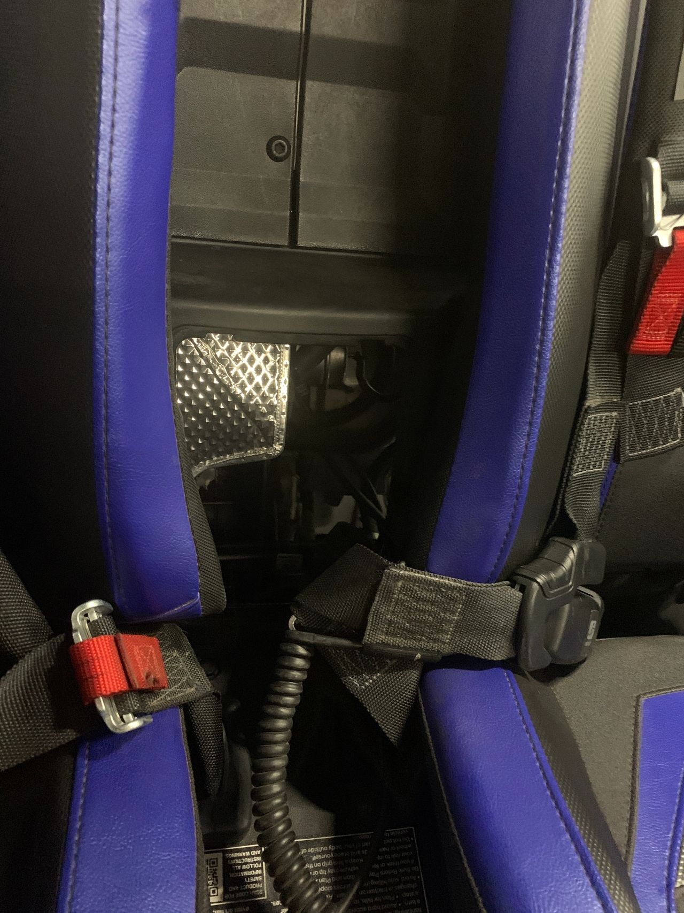
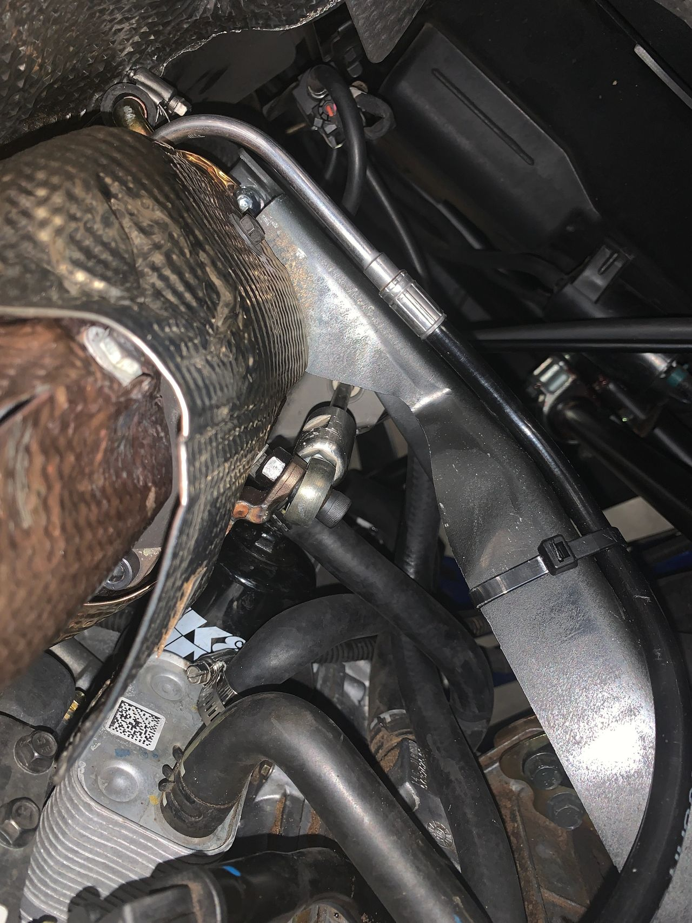
Step 2: Loosen the jam nut near the heim joint side of the linkage. Use a 17mm wrench on the center coupler with the 2 flat spots to hold the rod. Use a 13mm wrench to crack the jam nut loose. The jam nut has standard threads, so turn your wrench up towards the top of the motor. Spin the jam nut as far as possible towards the heim joint. See images below.
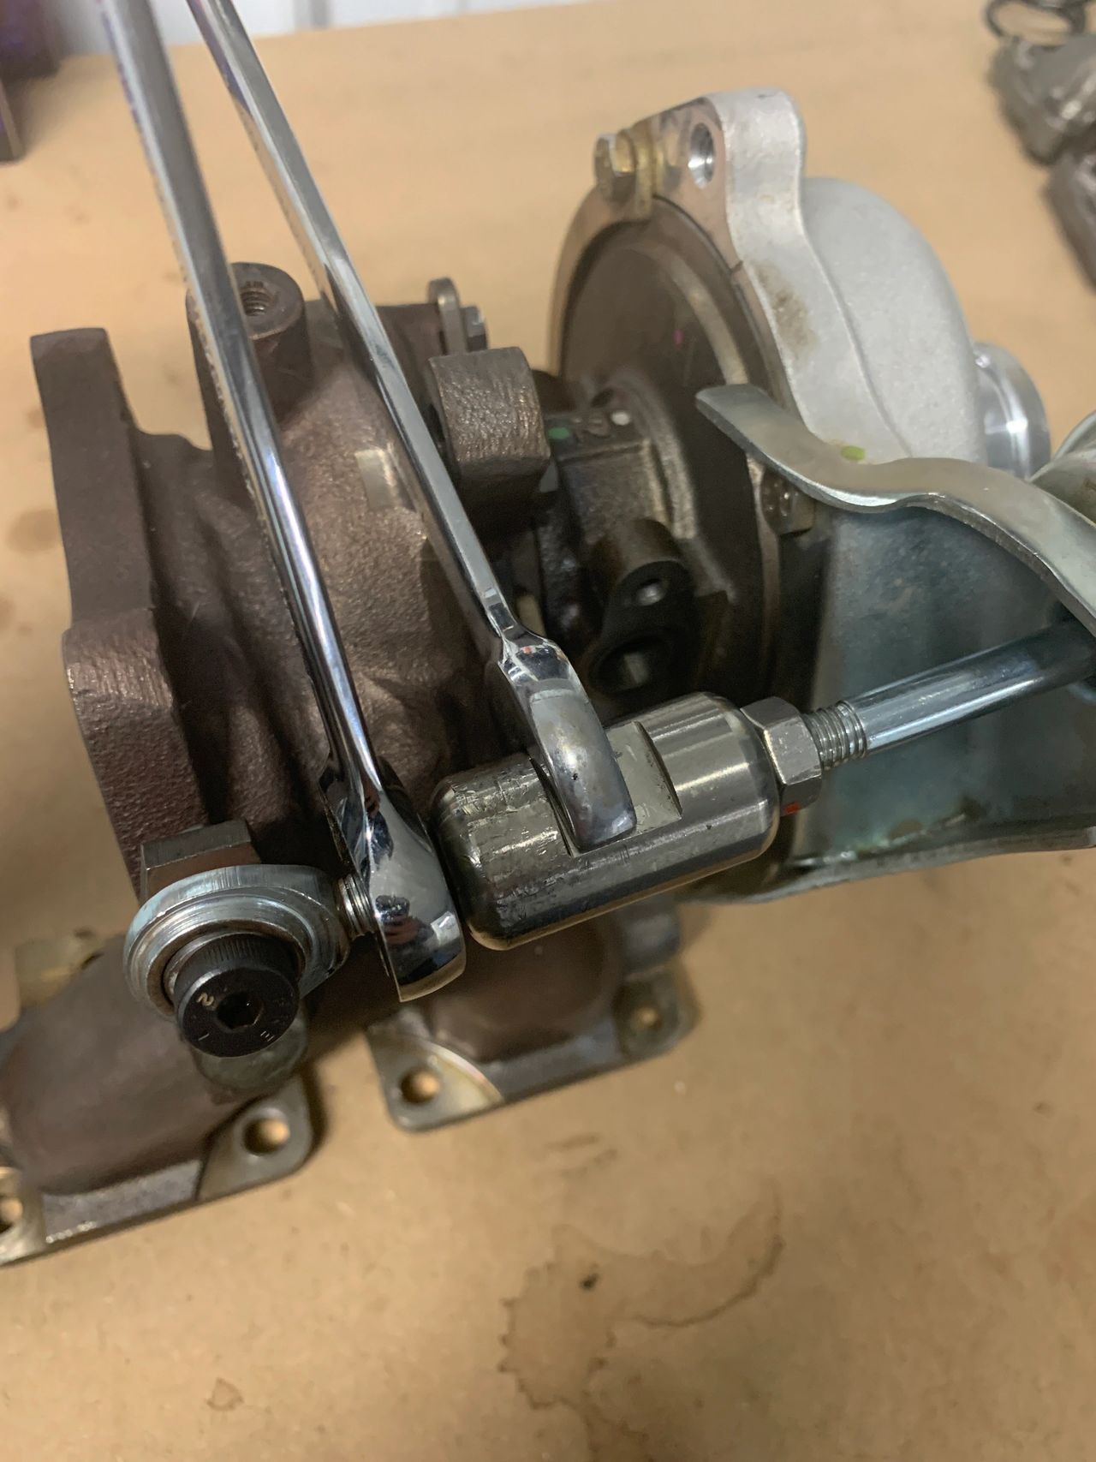
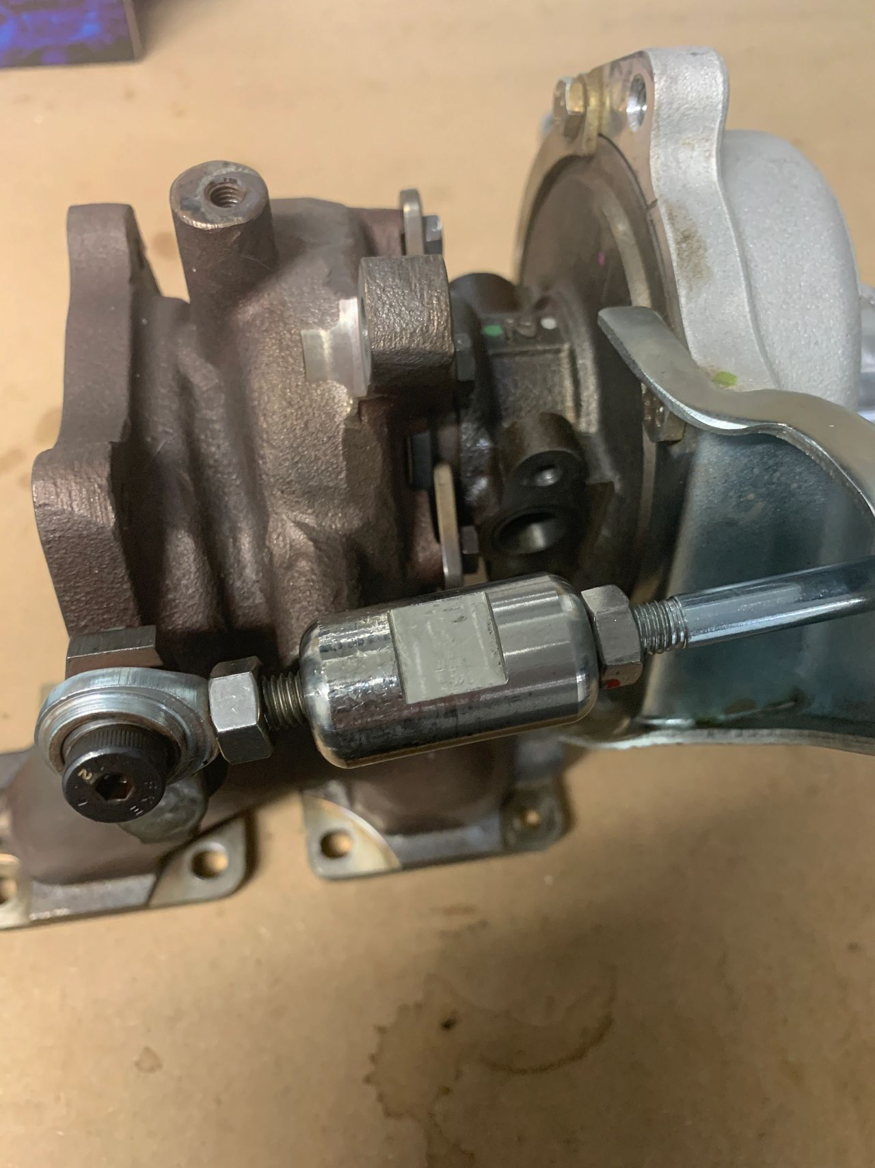
Step 3: Use your 17mm wrench and/or fingers to turn the center barrel upward (towards the top of the motor) which will thread it towards the heim joint. You will feel some resistance as it spins the rod inside the actuator(silver ball with the boost port). This will shorten the rod and gain extra spring pressure needed for more boost. Shorten the rod as much as possible as it will normally stop/bottom out just before it hits the jam nut. See image below of a properly shortened waste gate.
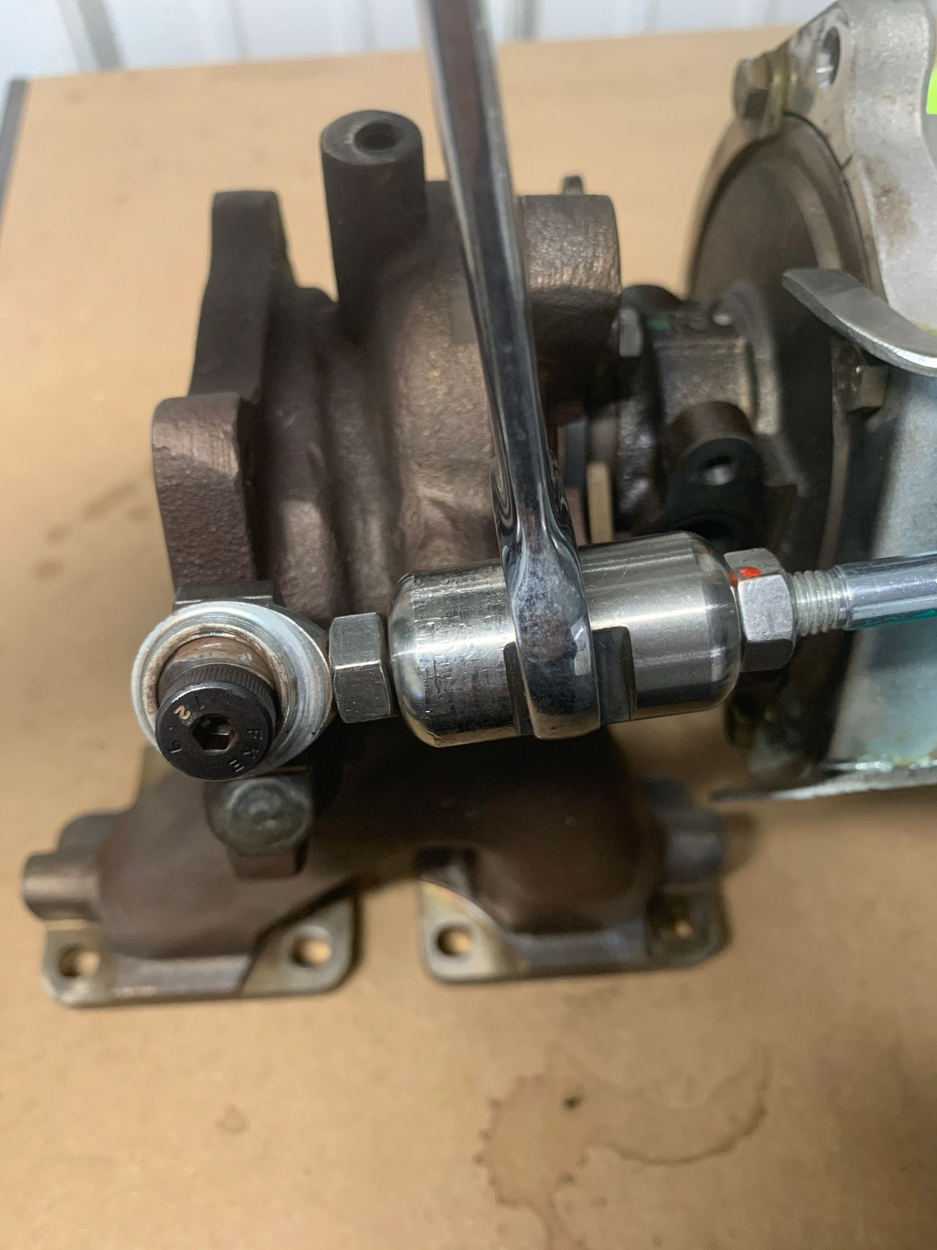
Step 4: Tighten the jam nut and install all other parts you removed from the vehicle.

Side Notes for waste gate adjustment
- If you purchased our waste gate pump to check crack PSI, stock should crack at 5 to 5.5psi
- Waste gate adjustment for AA tunes that require adjustment should be 6.5 to 7psi
- Crack pressure is when you slowly pump PRESSURE (not vacuum) into the waste gate actuator and see it first start to move
- Our older instructions/video use a pump to move the arm over and loosen both jam nuts, then spin the center coupler. This way works when the turbo is new but found the rod normally rotates in the actuator after being use. This newer method is much easier and requires less special tools.

